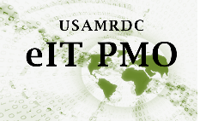
Instructions to Obtain an eIT PMO Product Account
Instructions for DoD military, civilians, or government contractors.

User Instructions
- Fill out and digitally sign Section A of the eIT PMO Account Request form (example below).
- Have a EDMS Knowledge Manager or POC fill out and digitally sign Section B (optional for EDMS, required for BLMS).
- Obtain a current DoD Cyber Awareness Challenge certificate.
  - Training and exam is available here for DoD users and available here for non-DoD users.
- If this is a BLMS request:
  - Review and digitally sign the Acceptable Use Policy.
  - Obtain a current HIPAA certificate.
- Email your DoD Cyber Awareness Certificate and signed Account Request Form to the eIT PMO Product Support Mailbox: mailto:usarmy.detrick.medcom-usamrmc.mbx.eit-pmo-help-desk@health.mil.

