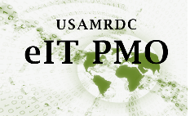Instructions to Obtain an eIT PMO Product Account

Instructions for DoD military, civilians, or government contractors.

User Instructions

1. User must complete and digitally sign Section A of the eIT PMO Account Request form (see example below).
2. Your Knowledge Manager or Supervisor can provide the EDMS permissions and digitally sign Section B of the eIT PMO Account Request Form. (If not, eIT PMO will email the KM to discuss permissions).
3. User must provide a current DoD Cyber Awareness Challenge certificate.
   1. Training and exam are available [here for DoD users](https://jkodirect.jten.mil/)
   2. Current Cyber Awareness Challenge certificates can be retrieved from your ATCTS account:

<https://atc.us.army.mil/iastar/index.php>

1. If this is a BLMS request:
   1. Use the eIT PMO - BLMS User Account request form.
2. Email your DoD Cyber Awareness Certificate and signed eIT PMO Account Request Form to the eIT PMO Product Support Mailbox: [usarmy.detrick.medcom-usamrmc.mbx.eit-pmo-help-desk@health.mil](mailto:usarmy.detrick.medcom-usamrmc.mbx.eit-pmo-help-desk@health.mil).

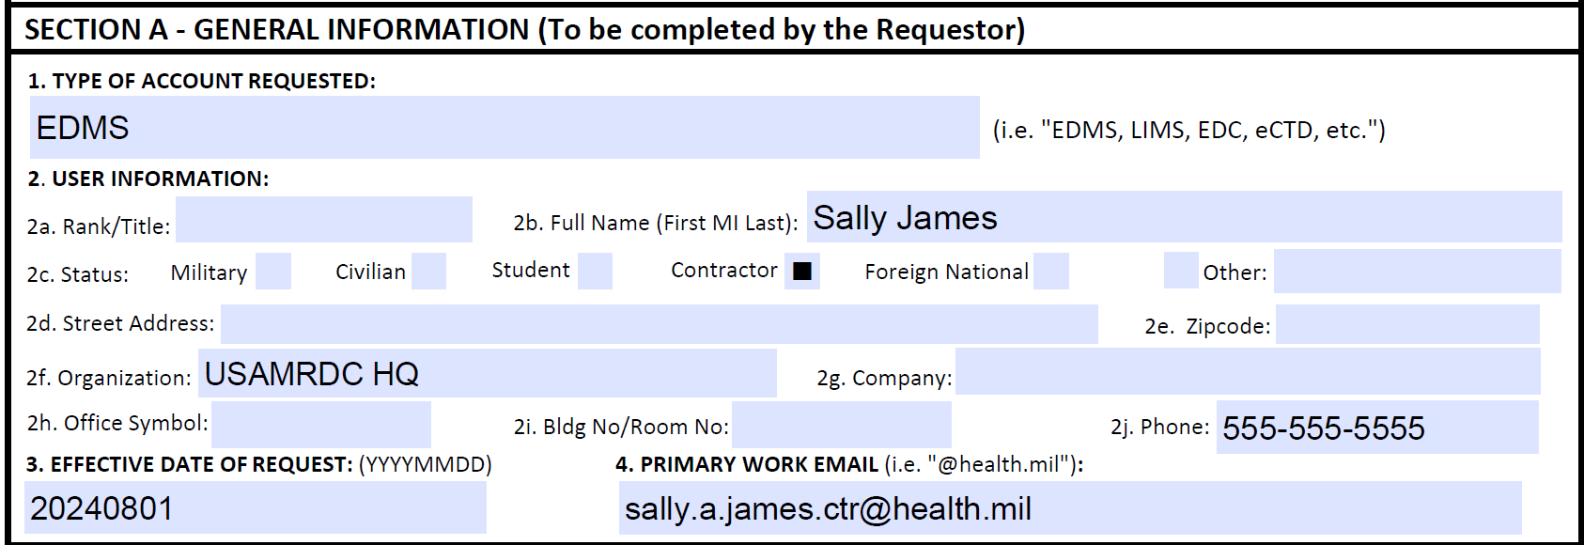 

**Digital signature not shown but is required.